**Lab Manual for Computer Communication and Networking**

**Lab No. 09**

**Open Shortest Path First(OSPF)**

**BAHRIA UNIVERSITY KARACHI CAMPUS**

**Department of Software Engineering**

**COMPUTER COMMUNICATION & NETWORKING**

**LAB EXPERIMENT # 09**

Dynamic Routing OSPF

**OBJECTIVE: -**

* This lab assignment helps in understanding how dynamic routing using Routing Information Protocol (OSPF) can be configured on routers.

**THEORY: -**

**OSPF Properties**

Open Standard

AD=110

Metric = Bandwidth

Makes 3-Table (Routing, Topology, Neighbor)

Hello packets = 10 sec

Dead Interval = 40 sec

Support Multicast

Algorithm = Dijkstra’s

**NETWORK TOPOLOGY: -**



**PROCEDURE AND OBSERVATION: -**

**Step01: Configuring OSPF routing on router 1**

Router1(config)#interface serial 0/0/0 (Configuring serial 0 port)

Router1(config-if)#ip address 15.0.0.1 255.0.0.0

Router1(config-if)#Clock rate 64000

Router1(config-if)#no shut

Router1(config-if)#exit

Router1(config)#interface fa 0/0 (Configuring fastethernet 0 port)

Router1(config-if)#ip address 10.0.0.3 255.0.0.0

Router1(config-if)#no shut

Router1(config-if)#exit

Router1(config)#router OSPF 1 (Configuring OSPF on router 1)

Router1(config)#network 10.0.0.0 0.255.255.255 area 0

Router1(config)#network 15.0.0.0 0.255.255.255 area 0

Router1# show ip route

**Step 02: Configuring static routing on router 2**

Router2(config)#interface serial 0/0/0 (Configuring serial 0 port)

Router2(config-if)#ip address 15.0.0.5 255.0.0.0

Router2(config-if)#Clock rate 64000

Router2(config-if)#no shut

Router2(config-if)#exit

Router2(config)#interface fa 0/0 (Configuring fastethernet 0 port)

Router2(config-if)#ip address 20.0.0.3 255.0.0.0

Router2(config-if)#no shut

Router2(config-if)#exit

Router2(config)#router OSPF 1 (Configuring OSPF on router 2)

Router2(config)#network 20.0.0.0 0.255.255.255 area 0

Router2(config)#network 15.0.0.0 0.255.255.255 area 0

Router2# show ip route

**Step03: Verify the route by pinging from Router 1 to Router 2**

Router2# ping 20.0.0.2 or

Router1# ping 10.0.0.2

**Step04: Verify the route by pinging from PC 1 to PC3**

C:\> ping 10.0.0.1 (from PC 1) or

C:\> ping 20.0.0.2 (from PC 3)

**QUESTIONS: -**

1. **Configure OSPF on the following network and show all necessary configuration steps for each router.**



**Solution**

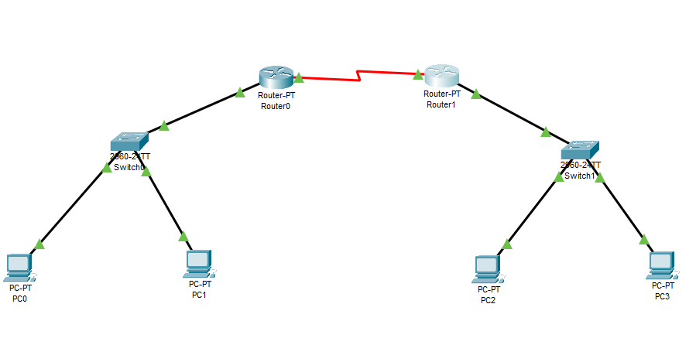

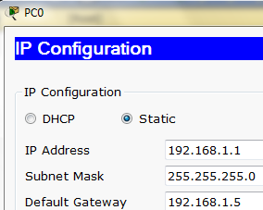

**Router 0**

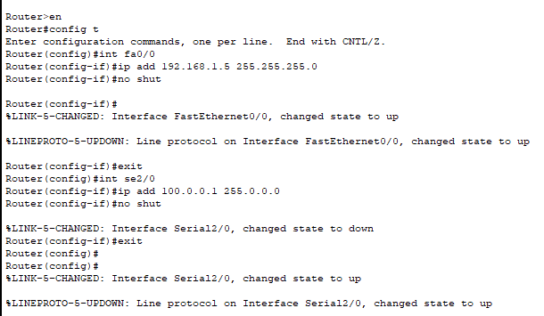

**Router 1**

**Setting OSPF on router 0**

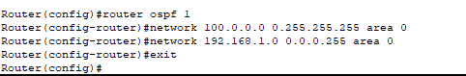

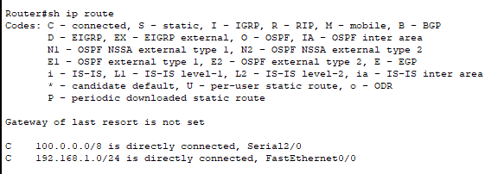

**Setting OSPF on router 1**

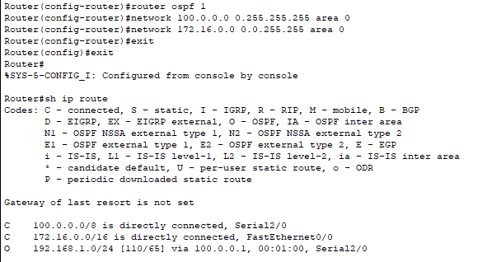

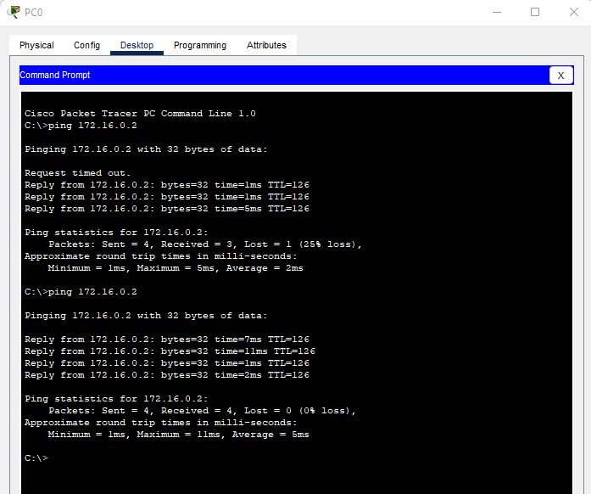

1. **Configure OSPF on the following network and show all necessary configuration steps for each router.**



**Solution**

**Router 0**

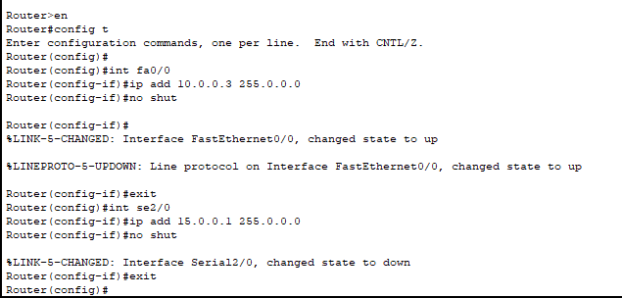

**Setting OSPF on router 0**

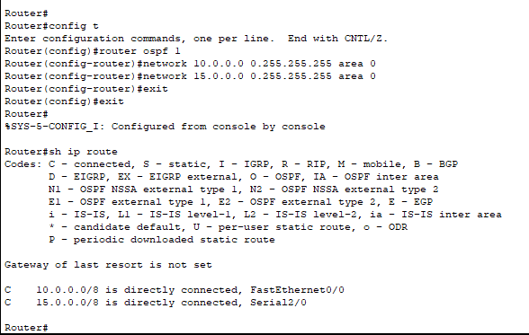

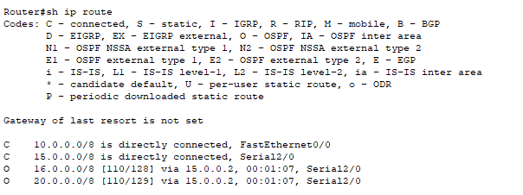

**Router 1**

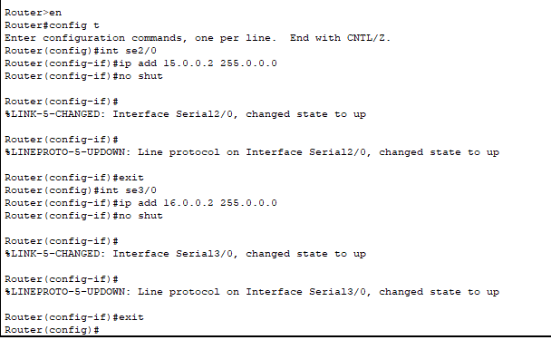

**Setting OSPF on router 1**

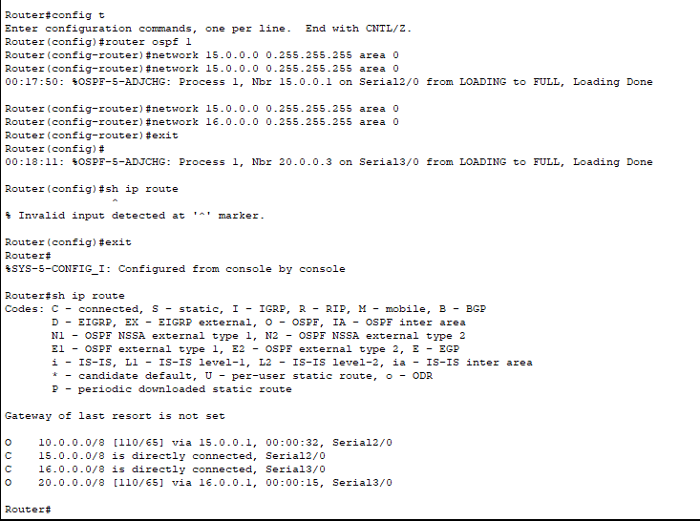

**Router 2**

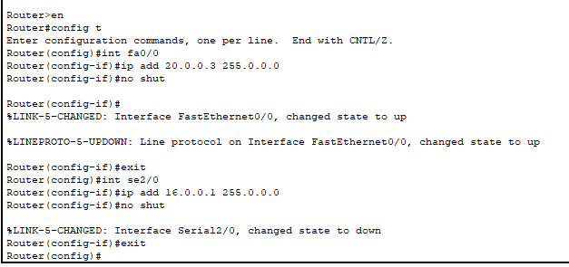

**Setting OSPF on router 2**

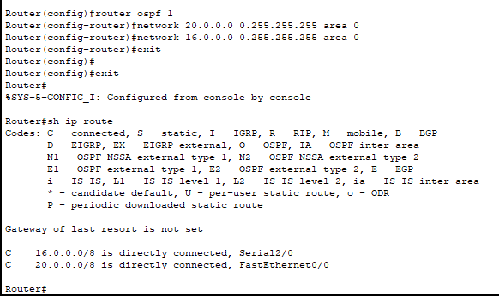

**Ping**

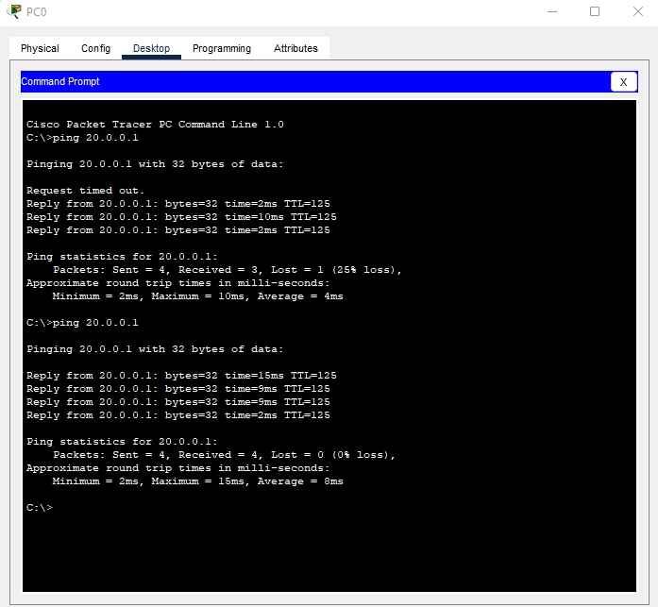

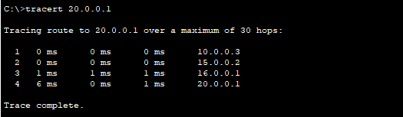

**TIME BOXING:**

|  |  |  |
| --- | --- | --- |
| **Activity Name** | **Activity Time** | **Total Time** |
| **Instruments Allocation + Setting up Lab** | 10 mints | 10 mints |
| **Walk through Theory & Tasks (Lecture)** | 60 mints | 60 mints |
| **Implementation & Practice time** | 90 mints | 80 mints |
| **Evaluation Time** | 20 mints | 20 mints |
|  | Total Duration | 180 mints |

**Teacher Signature**: ________________________

**Student Registration No**: ________________________